WORKSHEET 6.2

Static Review

1. Revisit your Rectangle Class from Lesson A4. Construct a 3x3 grid of Rectangle objects as shown below. You should be able to produce the grid with only 3 rectangles. In addition, calculate and display the perimeter and area of the rectangles. In order for you to create three different rectangles on a single DrawingTool object, you must make that DrawingTool object a static. Try writing the program both ways and see what happens when the DrawingTool is not created as a static.

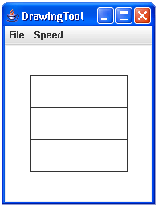

2. Create your very own class that contains some useful math functions called MyMath. Add the following formulas as static methods.

a. The two temperature scales used in the United States are Celsius and Fahrenheit. The mathematical relationship between the two scales is:

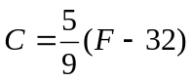

Write two static methods, fToC and cToF, which convert temperatures from one scale to another. For example, a call of fToC will return the equivalent Celsius temperature for a given Fahrenheit temperature.

Celsius = fToC(100); // Celsius now stores 37.8

b. Write a method that takes in the radius of a sphere and returns its volume. The formula is:

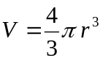

c. Write a method that returns the hypotenuse of a right triangle given the input of the two smaller sides. Use the Pythagorean theorem:

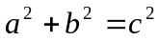

d. Write a method that accepts the coefficients of a, b, and c for a quadratic equation and outputs the real roots. Remember that a quadratic equation can be summarized in the form:

ax² + bx + c = 0

The method should compute the two real roots for the equation and print them to the screen. You don’t need to return any value and you don’t have to error-trap for a negative discriminant situation (if b2 - 4ac < 0).

x =

Here are some sample values to use in parts a, b, c, and d.

Fahrenheit to Celsius: 212oF, 98.6oF, 10oF
Celsius to Fahrenheit: -15oC, 0oC, 70oC
Volume of a sphere, radius of: 1.0, 2.25, 7.50
Hypotenuse calculations: sides of 3.0 and 4.0, sides of 6.75 and 12.31
Quadratic calculations:
x2 - x - 6 = 0 x2 + x - = 0 -2x2 + 5x + 17 = 0

